Consumers Energy
IMPLAUSIBLE EMMA CASE TRAINING

Basic EMMA implausible case training for contractors

Contents
(Control and click to access links)
STEPS TO PROCESS AN EMMA CASE 3
STEP 1. PULLING CASES 4
STEP 2. ACCESSING CASES PULLED 6
step 3. Verify no attached case 7
TO FORWARD CASE OR PUT CASE IN “IN PROCESS” 8
STEP 4. CHECK THE PREMISE ENVIRONMENT 10
STEP 5. CHECK RATE 12
STEP 6. ANALYZE ACCOUNT 14
CREATE ORDER 15
CATCH-UP BILL AND LEVELIZING PROCESS 19
CONSECUTIVE ESTIMATE PROCESS FOR PROACTIVE COMMUNICATION 20
STEP 7. MAKE CORRECTIONS 23
SECURITY DEPOSITS 34
RESETTING CLEARED ITEMS 36
STATISTICAL WRITE OFFS 38
STEP 8.INVOICE ACCOUNT 40
CHECK THE LOG AFTER INVOICING COMPLETED 42
STEP 9.COMPLETE CASE 43
AUDITS 45

STEPS TO PROCESS AN EMMA CASE

- Pulling Cases (EMMACL)

- Accessing Cases Pulled (/EMMAX/CLS)

- Verify no attached cases

- Check premise environment for other service

- Check rate

- Analyze Account

- Make corrections, release read, or forward case to In Process

- Invoice account

- Always check Log after invoicing

- Complete Case

Other possible training materials to review:
- Resetting Clearing Docs
- Manually Outsorting Invoices
- Removing Installment Plans
- FACTA Blocks

PULLING CASES
Access transaction code EMMACL to assign cases to yourself.
Insert the following:
- “Clarif. Case Category”- Case type assigned (ex..IP24, etc)
- Processing Status= 1 (New)
Remove 200 in the “Maximum No. of Hits” so you are able to pull up all cases
Hit Execute
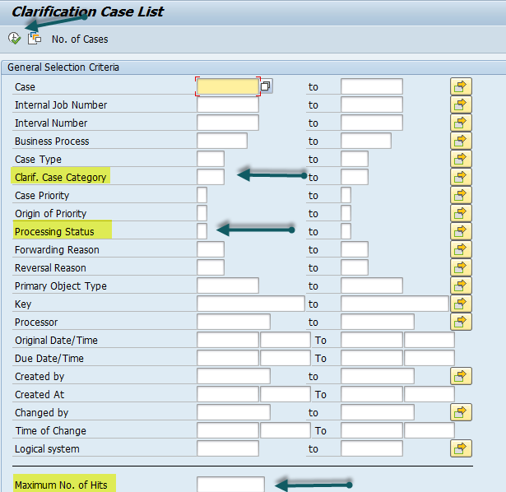

Highlight 25 cases. Click Accept. The cases are now assigned to you.
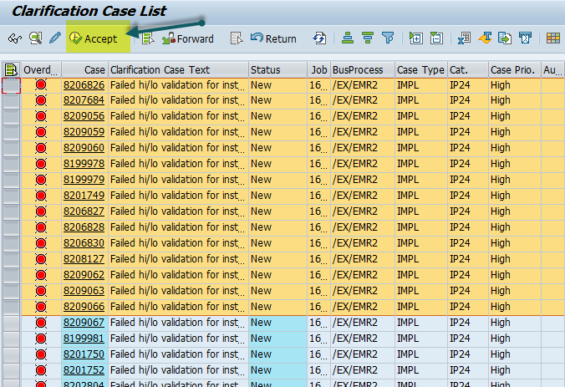

ACCESSING CASES PULLED

Access transaction code /EMMAX/CLS

Click on the Partner number*

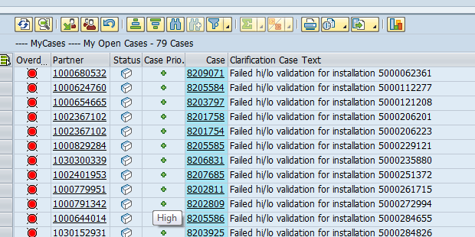

* Without a Partner number- Double Click on the Clarification Case Text

VERIFY NO ATTACHED CASES

You will ONLY work the cases associated with the installation number in the key field as your EMMA case. If an attached case is already assigned to another billing agent, you will forward YOUR case to that person. *Please see next step on forwarding process.
If there are no other EMMA cases attached, please proceed with your case.
If your EMMA has any other cases attached that you have NOT been trained on, you will need to forward to In Process.
The cases below are generated when the meter number in our system and the meter number in the field do not match. Review meter read results to determine if meter has recently been exchanged AND that the meter reads are in line. If so, please proceed with your case.
If you have not been trained on placing field orders, forward your case to In Process.
- ERNN Elec Res Number Correction
- EXNN Elec Secondary Number Correction
- EXMN Electric Number Correction
- GXNN Gas Basic Number Correction
- GRNN Gas Res Number Correction
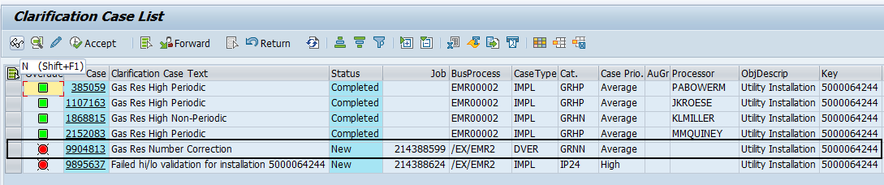
If a “meter verify” order already exists, email the individual who created the order. Please be sure to include your EMMA case number and ask that they notify you when their corrections have been completed.
If a meter verify order does not exist and you have been trained, create meter verify order requesting the device number and the meter read. Note your EMMA case and proceed/complete once the field results have been provided.

If the attached case is a Dial Error case, then follow the process below:

- Check to see if there are any open/pending exchange orders
- IF there is any OPEN orders- HOLD your case
- IF there are NOT any open orders- Work your case as normal
- Do not close the attached Dial Error case- these are worked by Trisha Emert each month

- GRDN Gas Res Dial Error Non-Periodic
- ERDN Elec res Dial Error Non- periodic
- ESDN Elec Secondary Dial Error Non-Periodic
- EXDN Electric Dial Error Non-Periodic
- GBDN Gas Basic Dial Error Non-Periodic

TO FORWARD CASE OR PUT CASE IN “IN PROCESS”

Attached case in a Billing Agents name:
- Enter the Billing Agents user ID in the Processor field.
- Change the “Forward due to” field by double clicking the forwarding reason “Z003”
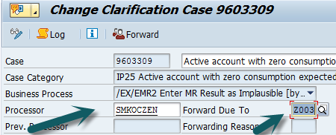
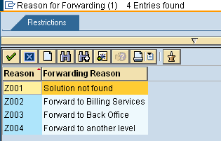

Forward case to “In Process” when necessary:
- Delete your name from the Processor field
- Enter a Forward Due to reason (see above)
- Enter a short explanation as to why the case is being forwarded.
- Click on “Forward”. Select appropriate category
  - Team_CA- Special Ledger(Business Customer Billing)
  - Team_LANSAG- All cases not yet trained
- Click on the green check mark
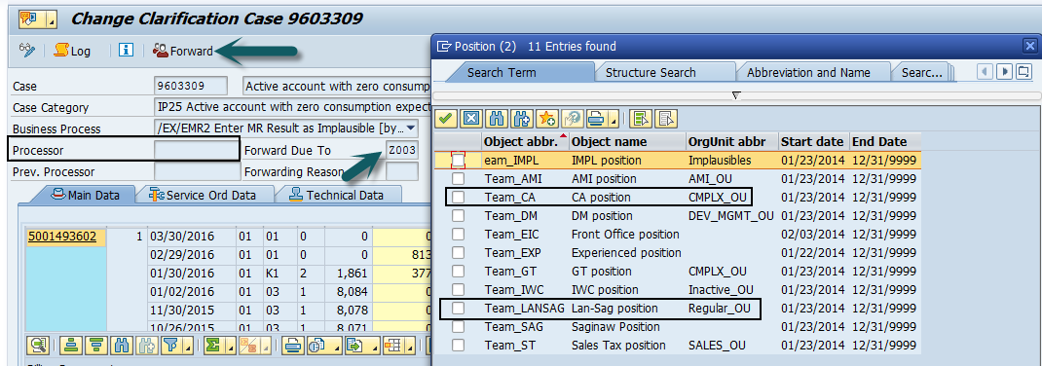

OPENING EMMA CASE

Double Click on Clarification Case Text to open case.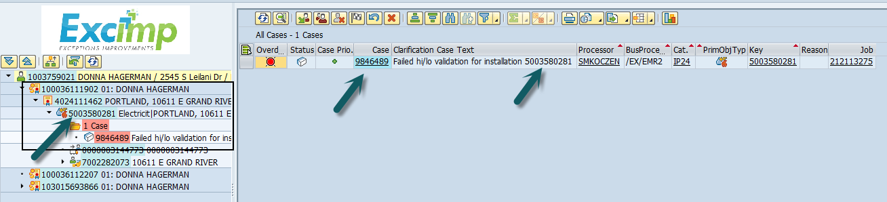

PREMISE ENVIRONMENT
Click on premise environment, to check the rates and determine if premise has gas and electric.
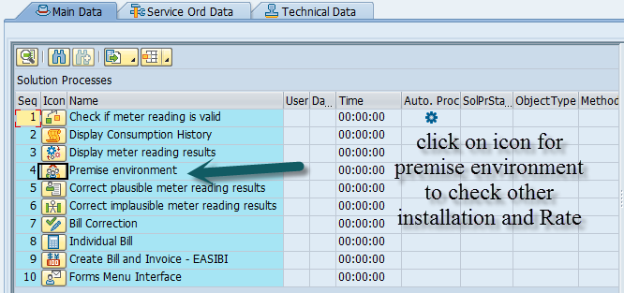
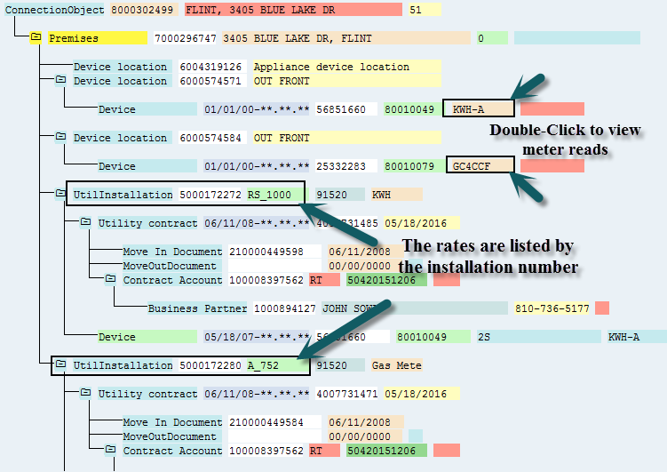

Rates commonly worked by billing agents:
Electric Rates:
- RS_1000 (residential)
- GS_1100 (small commercial)
Gas Rates:
- A_250 (residential)
- A_752 (Gas Customer Choice - residential)
- GS_261 (small commercial)
- GS_262 (Gas Customer Choice – small commercial)

We should not be working any GAS TEMPERATURE CORRECTOR accounts.
These accounts will need to be sent to PO BOX: Special Ledger with “Gas Temp Corrector” in the subject line.
To identify these meters you will need to double click on the meter number:
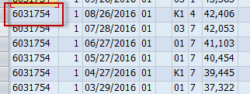
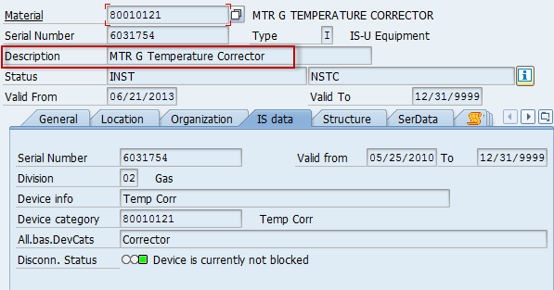

If your case is on a rate from the list below, forward your case to Team_CA (Complex Billing) and send an email to PO Box: Special Ledger and include a screen shot of the case information.
See TO FORWARD above.
These rates should NOT be worked by Customer Billing agents:

Gas Rates | Electric Rate | Electric Rate | Electric Rate
GS_265  GS_266 | GP_2210V1 | AR_1115 | GPD_2220V2
GS_267  GS_268 | GP_2210V2 | AR_1125 | GPD_2230V1
GS_269 | GP_2200V1 | AR_1135 | GPD_2230V2
GS_271 | GP_2200V2 | AR_1205 | GPD_1220V1
GS_273 | GP_2200V3 | AR_1215 | GPD_1220V2
GS_275 | GP_1210V1 | AR_1225 | GPD_1220V3
GS_270 | GP_1210V2 | AR_1235 | GPD_1230V1
GS_272 | GP_1200V2 | AR_1015 | GPD_1230V2
GS_274 | GP_1200V3 | AR_1105 | GPD_1230V3
GS_276 | GP_2210V3 | REV1020 | GPD_2220V1
GS_283 | GP_1210V3 | REV1030 | GPD_2220V3
GS_284 | GP_1200V1 | REV1040 | GPD_2230V3
GS_285 | GP_1200 | RT_1010 | PMM_1250V1
GS_286 | GP_1210 | GSG_1300 | PMM_1250V2
GS_287 | GP_2200 | GSG_1305 | PMM_1250V3
GS_288 | GP_2210 | GSG_1310 | GUL
A_043 | GSD_1120 | GSG_1315 | PS1_077
A_052 | GSD_1130 | GSG_1320 | PS1_557
A_043 | GSD_1140 | GSG_1325V1 | PS2_078
A_052 | GSD_1150 | GSG_1325V2 | PS2_558
A_753_GSM | GSD_2120 | GSG_1330 | PS3_079_V1
A_251_GSM | GSD_2130 | GSG_1330V1 | PS3_079_V2
GT_PRIMARY | GSD_2140 | GSG_1330V2 | PS3_079_V3
 | GSD_2140 | GSG_1330V3 | PS3_559_V1
 | GSD_2150 | GSG_1340 | PS3_559_V2
 | GPT_1280V1 | GSG_1345V1 | PS3_559_V3
 | GPT_1280V2 | GSG_1345V2 | GML_1400
 | GPT_1280V3 | GSG_1345V3 | GML_1405
 | GPT_1285V1 | GSG_1350V1
 | GPT_1285V2 | GSG_1350V2
 | GPT_1285V3 | GSG_1350V3
Any PMM rates
*Solar Garden Rates beginning with “SG”

If it is a combination account, double-click on the device (see previous premise environment screenshot) to check the meter reads for the other installation (i.e. if your case is an electric case, look at the gas from premise environment).
If it not a combination account, proceed with working your EMMA case.
Click on MR Results
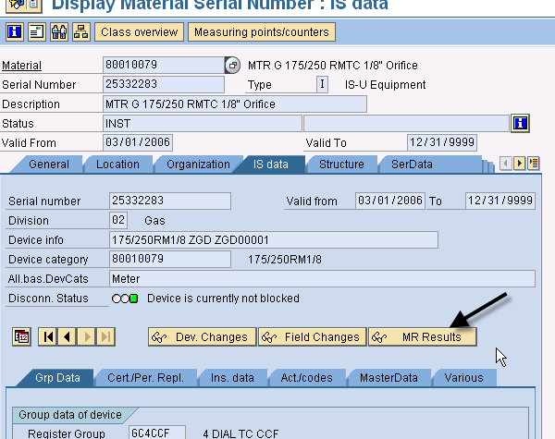
Additional scenarios that should not be worked and forwarded to Team_CA (Complex Billing):
Do NOT work accounts with MA in the MT field. (MV90)
Also look for CO in the MT field. This could be an indication of a Net Metering account. There will also be a CB block.
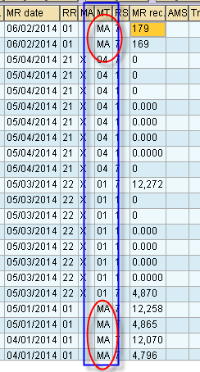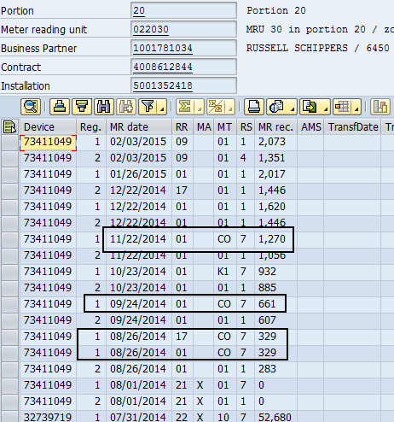
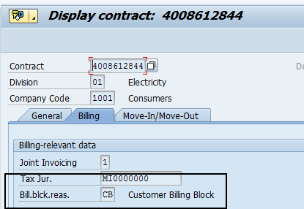

On the Meter Reading Results screen, check for an implausible read (indicated by a 2 in the RS column). 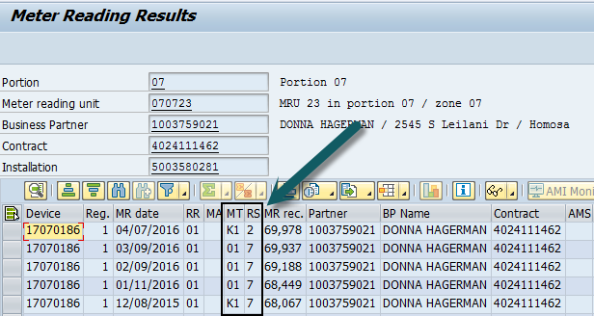

If there are no implausibles, continue on with your case.
If there is an implausible, check for an EMMA using EMMACL by entering the installation number in the key field.
- If there is a case without a current processor, forward the case to yourself.
- If there is a case with a current processor, forward your original case to that processor.
- To forward an EMMA case to yourself OR to another billing agent, see “forward to” process.

Analyze Account
Analyze the account to determine if the implausible read(s) can be released or if an adjustment needs to be made.


Meter reading Reason= RR
Periodic read= Monthly meter read and bill (01)
Non-Periodic read= A read in between monthly reads
03-Move out read
06- Move in read
09- Interim read
11-Temp Area Changed- Estimate
16- Temp Area Changed- Estimate
17- Temp Area Changed- Estimate
13- Turn off
18-Turn on
21-install
22- Remove
Meter Reading Type=MT
01-Company Read
02- Customer Read
03 & 04-Estimate
05- Adjustment Reversal
06-Internet Read
08- Meter Reading Error
09- Meter Reading Error Correction
10- Adjustment
12-Estimate
CO- Consumption Override (Non Reg Billing)
ET-Theft billing
K1-Read Okay

USAGE IS LOW
- Was last month actual read or estimate?
- # of Days in the billing period
- Past Consumption – is it normally low this time of year?
- Other service – Is other service low also? (not counting low gas use in the summer)
- Interaction records in front office– Vacant? For Sale? In Nursing Home? Change in family size, Etc.
- Pending or Recent Move out?
- Installation – Facts – Seasonal/Alternate Residence Flags (Note: even if seasonal or alternate residence, if zero use for the last 24 months and no vacant notes, send an order)
- What name is on the account? Current Occupant should be low or zero use; Check the premise to see if the customer is the landlord; Is the name a real estate company, bank/foreclosure, apartment complex?
- Is it a barn or irrigation pump (Should be commercial rate)
- Meter Reader Notifications: Vacant, etc.
- Is there a special mailing address?
- Estimated MI/MO
- Orders – is there a turn off pending? Non-Reg investigation in the last 24 months? Has the account been SNP (sealed for non-pay)?

If there is no reason found for low use:
First month low or zero: Release implausible, note case, complete case
2 or more months low or zero use: See Non Reg Process job aid

USAGE IS HIGH
- Is read lower than last month’s read?
- Were previous month(s) estimated too low?
- Read error? 100 or 1000 high or way off? Check orders for possible exchange. Only change actual read if good history.
- New customer? Last year vacant or in landlord name
- Number of days in the billing period
- Weather – very hot = higher air conditioning bills in summer; very cold = higher heat bills in winter….Pool heater, hot tub, space heater, etc.
- Electric Heat
- Gas is disconnected, using electric for heat
- Check work orders for possible field notes
- Estimated MI/MO
- Grain dryers – 1 or 2 months of very high (10,000+) typically seen in the fall

CATCH-UP BILL AND LEVELIZING PROCESS

See Consecutive Estimate Process

- When no Adjustments are required:
Click on (EL27)
If read is correct, click the checkered flag to release the implausible read and save.
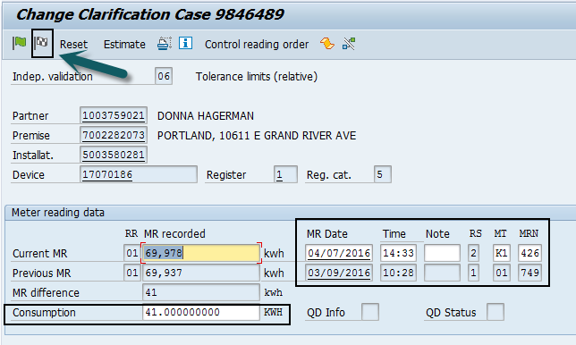

TO INVOICE ACCOUNT:
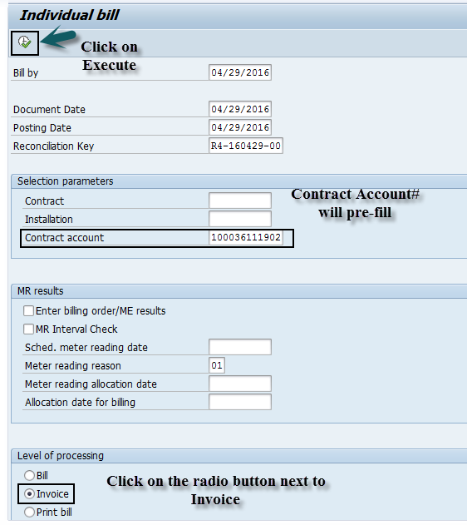
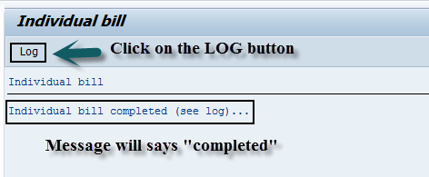

Adjusting an Implausible Read
Click on (EL27)
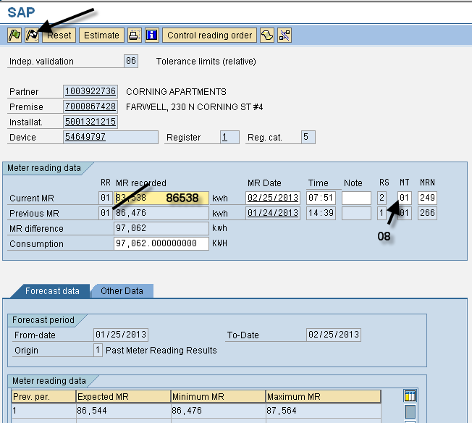

Correct the meter read and update the meter read type (MT column).
Typically in this screen, you will use the following MT:
Meter Reading Type=MT
08- Meter Reading Error
10- Adjustment

When to code as a meter read error (adj code 08):
- Must be actual periodic read (NOT customer read, estimated reads, move in/out reads, and/or disconnect/reconnect)
- When the meter read is off by more than 1.0 mcf or 10 kwh
- Must be within last 3 months.
Note: Do not change an actual read if there is not good read history (i.e. multiple estimates, or previous adjustments).

When to code as an adjustment (adj code 10):
- Correcting an estimated read that is out of line from history
- Correcting a customer read
- Correcting a disconnect/reconnect read
- Correcting an actual meter read that is off by LESS than 1.0 mcf or 10kwh

Once all corrections are made, invoice the account.

Correcting A read that has billed
- Adjustment reversals
- Full reversals

Adjustment reversals
When to use this process:
- Combination or single installations
- Overestimated 1 months or more
- Still levelize back to last actual read or up to 12 mths (Can use adj on more than 12 months)

Determine how many months need to be adjusted. In this example, the previous month was overestimated so you only need to cancel back 1month.
Click on the “Bill Correction” Icon
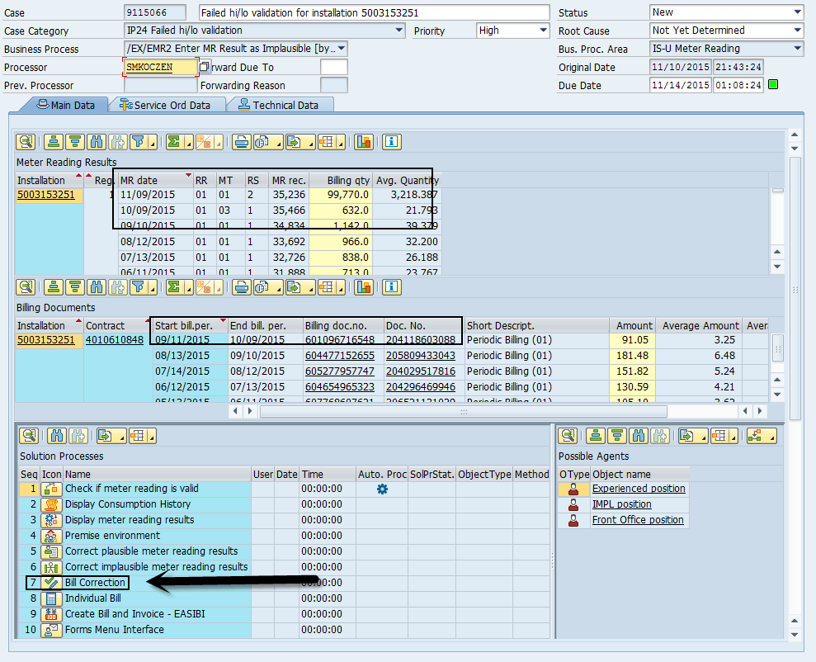

- Click on the bill document you need to cancel & then click on the green check
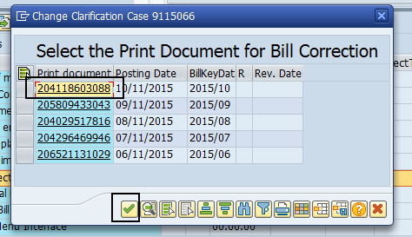

- Click in the box under the AR column, input today’s date under “Psting Date” and then select reversal reason “Over Estimated”. Click on the REVERSE icon.

Single installation:
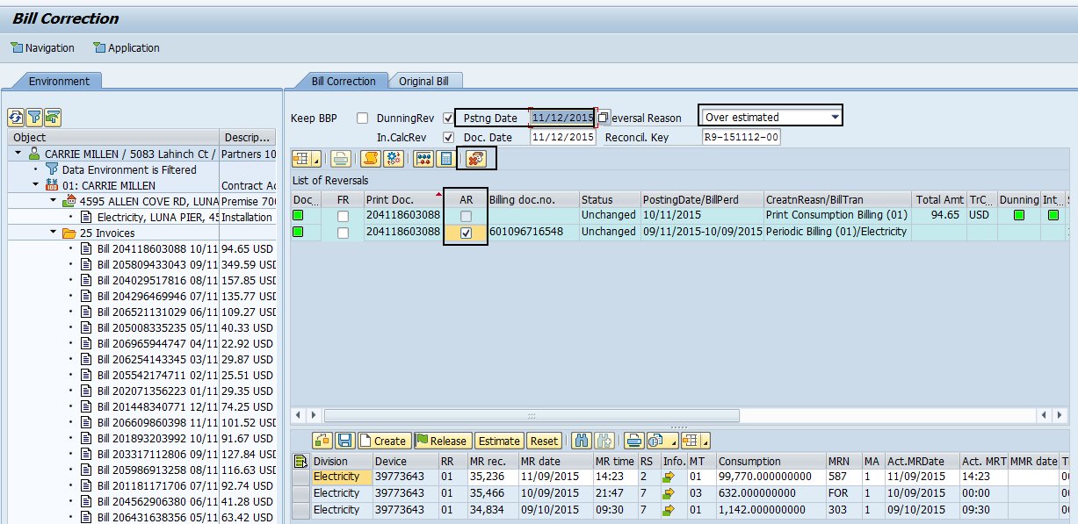

Combination installation:
Click in the box under the AR column for the installation you want to reverse, input today’s date under “Psting Date” and then select reversal reason “Over Estimated”. Click on the REVERSE icon.
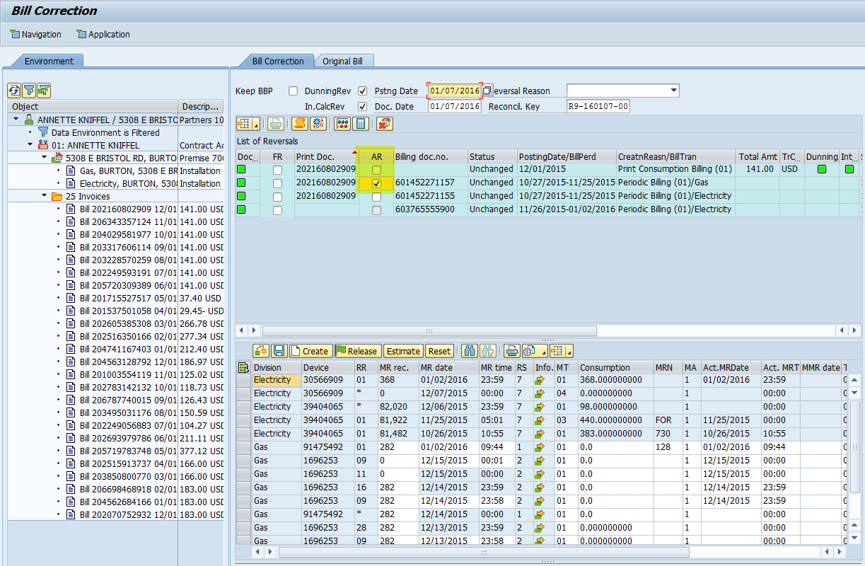

- You should see message at bottom 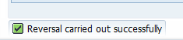

- Click on the gears icon to open up the meter reads for adjustment

- Highlight on the implausible read & click on the “Release” button
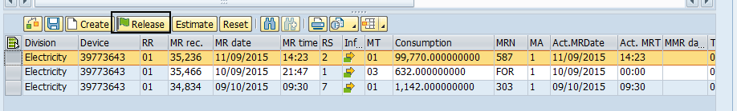

- The estimated read will automatically adjust by the system. Change the MT Type to “05”. Click on SAVE
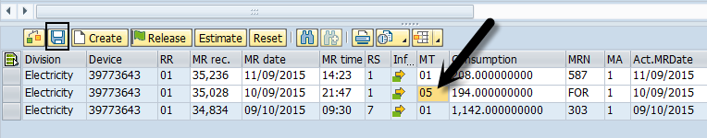

- Go Back to Case & Click on Individual Bill or Create Bill and Invoice to invoice
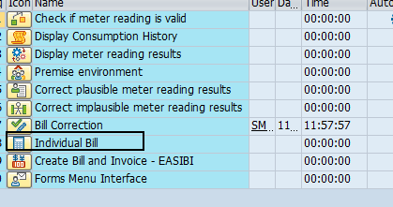

- You will select ALL the bill documents (for single and combination installations) and then click on the green check mark.
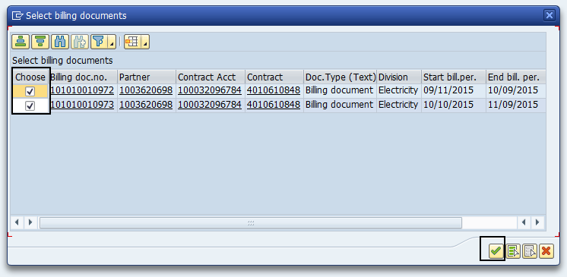

- Put notes on your emma case to indicate that an AR was done.
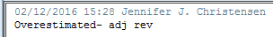

The MR Monitoring screen will show the “05” for the read
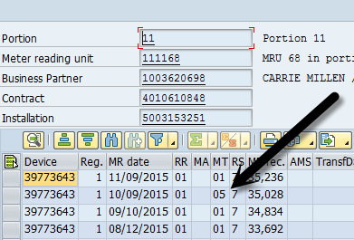
The billing documents will have the same invoice number
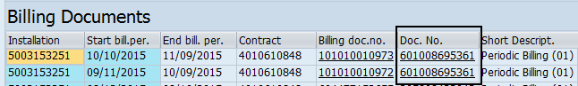

The bill will show as an E or G adjustment
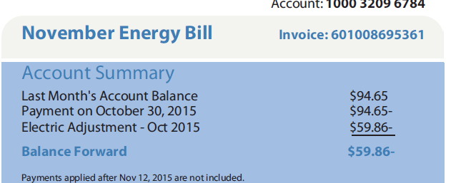

Full reversals
When to use this process:
- Previous reads are underestimated
- Demand/multiple register accounts
- MI/MO corrections
- If the most recent periodic read is too high (overestimated, read error, etc.)
- Business Center Accounts

Click on Bill Correction
(EABICO)
Select the Print Document for the date you want to cancel back to and click on the green checkmark.
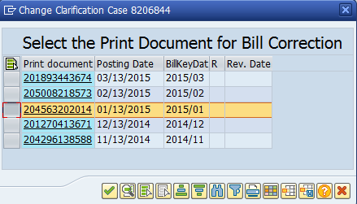

Enter today’s date in the “Psting Date” field.
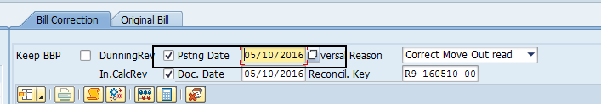
If you receive a “Cost Element” error, it is because the Posting date field was left blank.
- Click FR check box. By clicking the top box, the following boxes will become checked.
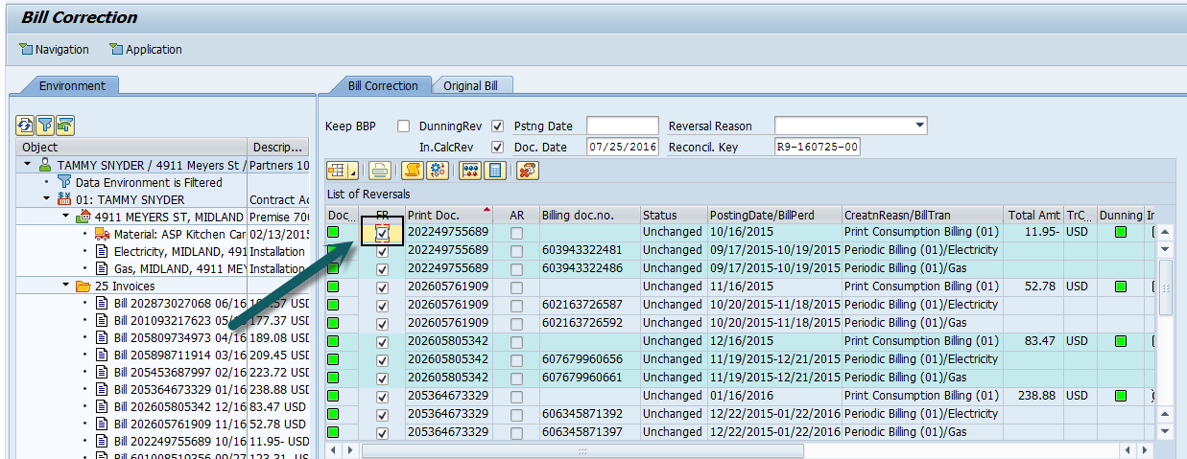
- Select the reversal reason the best applies to the situation
Most commonly used reversal reasons:
- Correct Move In date
- Correct Move In read
- Correct Move Out date
- Correct Move Out read
- Customer read correction
- Meter Read Error
- Overestimated
- Underestimated

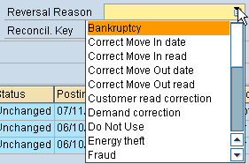
Less commonly used reversal reasons:
- Do Not Use
- Incorrect Invoicing
- Meter Malfunction
- Incorrect Rate
- Bankruptcy

- Reverse
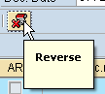

The following message will be displayed when the bill(s) are reversed successfully.

- Select gears icon to display meter reads:

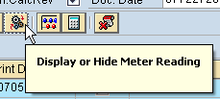

- Highlight the line with the implausible and select RELEASE.
- Adjust previous reads as needed and update the meter read type
- Hit Enter to validate reads
*** If the adjustment creates additional implausibles in the RS column, release the oldest implausible read first. ***
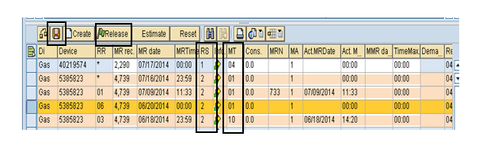
Click save.
Select green arrow back (F3)
Invoice account.

correcting read for previous customer
- Open another back office session EABICO (Bill Correction screen)
- Enter the final bill Doc. No. and select execute
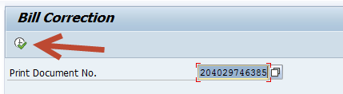
Enter today’s date in the “Psting Date” field.

- Choose reversal reason (Correct Move Out read)

2. Check FR box associated with “FINAL BILLING FOR MOVE OUT”
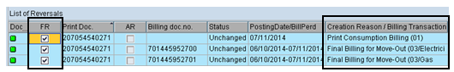
Occasionally when reversing a final bill, the previous month print doc will show up as well.
If you only need to cancel the final bill, select ONLY that print doc.
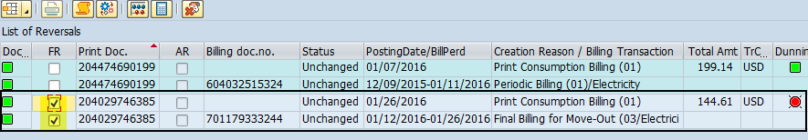

- Reverse

The following message will be displayed when the bill(s) are reversed successfully.

- Before you make corrections, green arrow back (out of the Bill Correction screen).
- Without changing Print Doc No field, EXECUTE to re-enter Bill Correction screen to display the current and previous customers meter reads.
- Highlight the line with the implausible read and select “Release”. 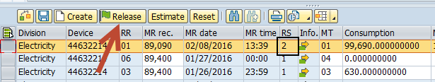

- Highlight your move in/move out reads and select “Estimate”. 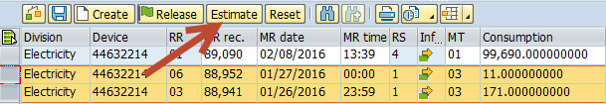

- Update the MT type to 10 and hit enter to validate reads.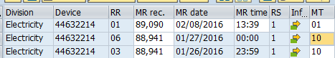

Click Save

Green Arrow back (F3)
Invoice account.

REVERSING BILLING DOC NUMBERS
This occurs when the account doesn’t get billed or reversed fully.
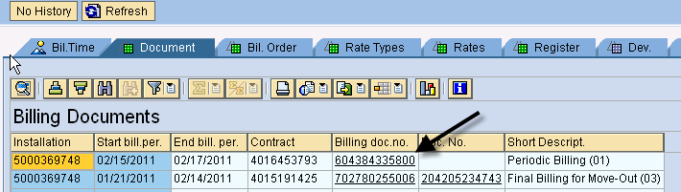

Copy the billing doc no. by right-clicking it and Ctrl+Y, Ctrl+C. In back office, use transaction code EA20 (Reversal of Billing Documents).
Paste document # and select reason for reversal. Execute.
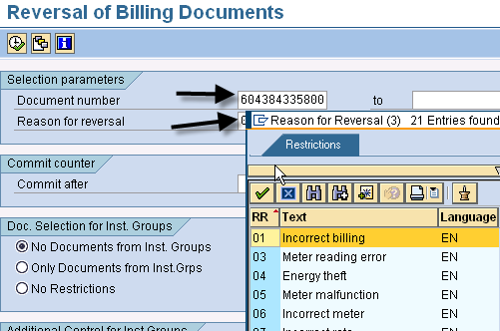
You will get this message that it worked. If you receive a message that says terminated, check the log to see why. You may need to reverse a late payment charge.
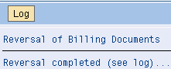

STEP 8. INVOICE ACCOUNT

to invoice CURRENT customer ONLY:
*If a move in/move out has taken place, invoice the previous customer first.
**If an AR has been performed, see job aid for invoicing AR accounts.

- From your case select Create Bill and Invoice (EASIBI)
- The contract account field is prefilled with current customer’s account number.
- Select the radio button for Invoice.
- Execute
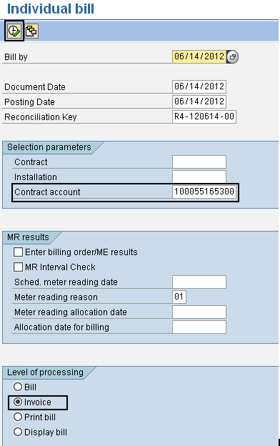

- Invoice the accounts beginning with the oldest month first.
- All billing docs will display, invoice each month separately. If it’s a combination account, always invoice gas and electric together.
- If gas and electric docs are not displayed, investigate before proceeding.
- If there are SD docs (Appliance Service Plan), include 1 SD doc with each month also.
(This example is for a gas only account with ASP)
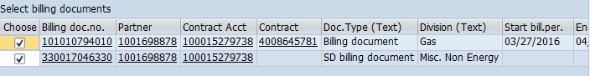
(This example is a combination account without ASP)
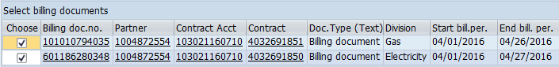

(This is an example of an account with multiple docs with the same month for a move out customer)
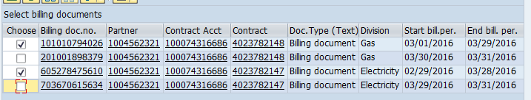
(Trainer, please elaborate on why end bill dates may not match)
Invoice each subsequent customer. Always check the log after invoicing each customer.
If you get a terminated message when invoicing, check the log for additional details, correct the issue and invoice.
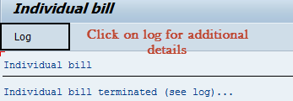

INVOICING Previous customer:
- Click on the CONTRACT number to display account number.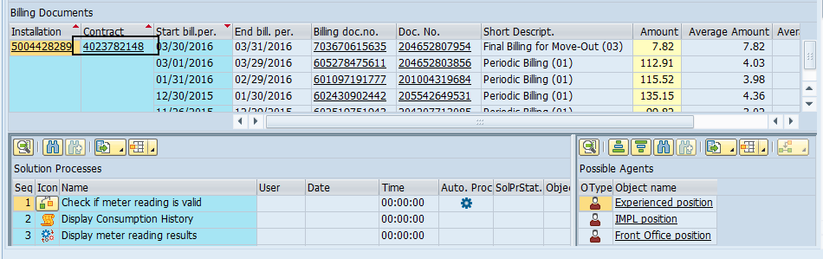
- Copy account number from Contract Acct field.
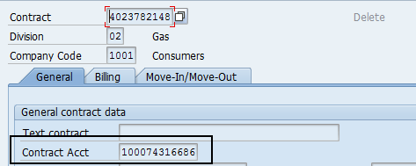

- In another session, open Individual Bill screen (EASIBI), paste the contract account number in respective field, select “Invoice” and “Execute”.
- Continue with invoicing process
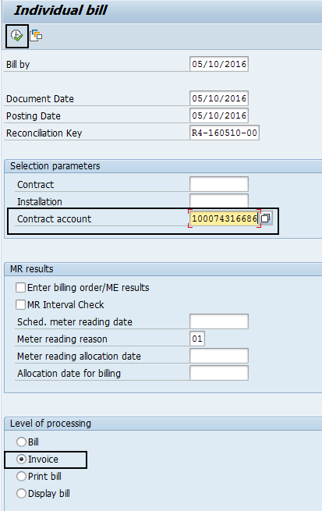

CHECK THE LOG:
Usually you will receive a message that invoicing has been completed. ALWAYS check the log after invoicing for any error log details, including outsorted documents.
If the bill has outsorted, the outsorted billing document will be displayed with a yellow triangle.
Example of an outsort error message:
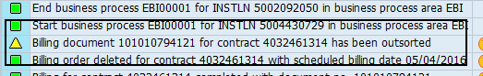

If you receive the error message for an outsorted document, please review your meter reads and correct any errors. If reads appear correct, please see job aid for EA05 Releasing Outsorted bills.
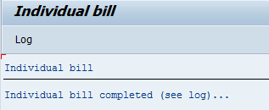
In our example, there are no yellow triangles and this case is complete. 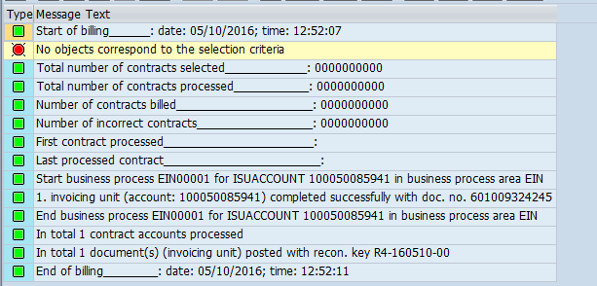

CLOSING YOUR EMMA CASE

Update your EMMA status to Completed and select Root Cause: Manual review needed
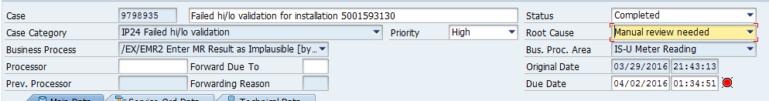
Copy a note from the “Emma Notes” document and paste into note section.
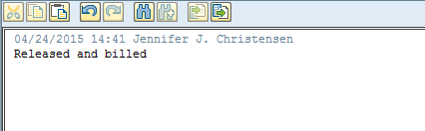
Hit SAVE
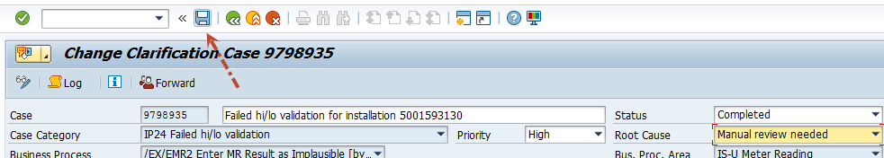
Once you save, it will take you back to this screen. Hit the green arrow to go back.
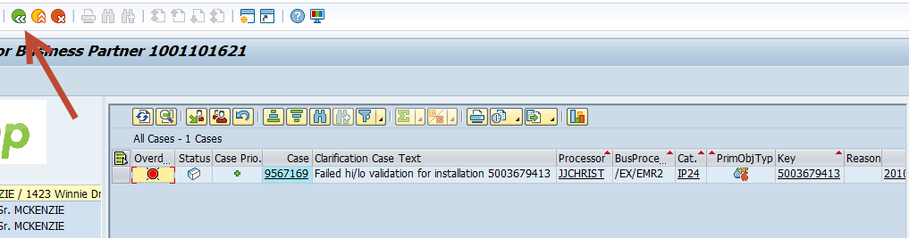

You will go back to your assigned cases. Hit the refresh button and your completed case is now identified with a diamond. Proceed to next EMMA case.
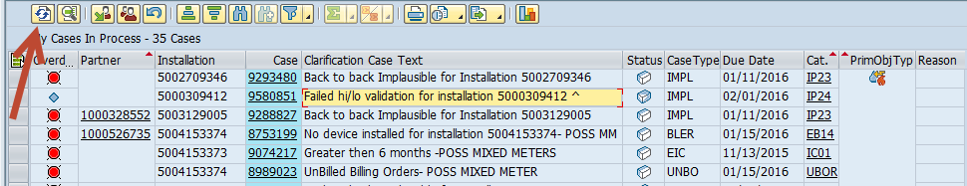

CREATE ORDER

Access account in front office. Click on Order Management in the blue navigation bar.
Click Create Work Order.
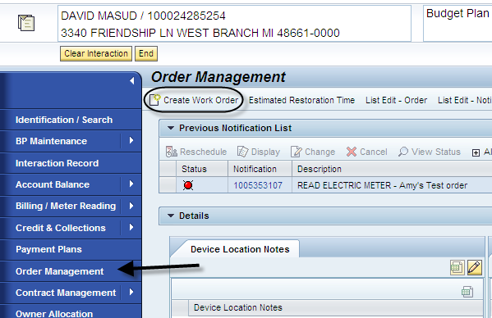
Click hot key for order needed.
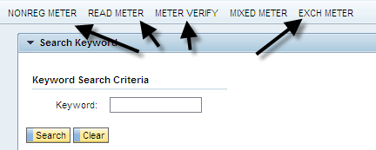
Fill in fields. Caller name = customer billing, No Phone, Internal CE Employee, your name.
Notify me and Group = Customer Billing. Then Click Next.

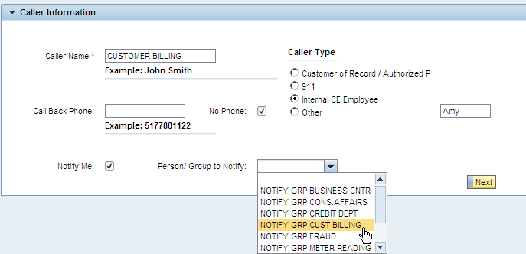
Select service by highlighting the line, then click next.
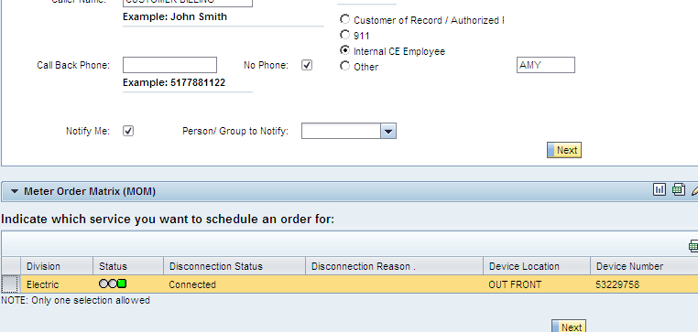
Double-click a day that is open. Red “X” = schedule closed. Enter pertinent info in additional text field. Then Submit.
